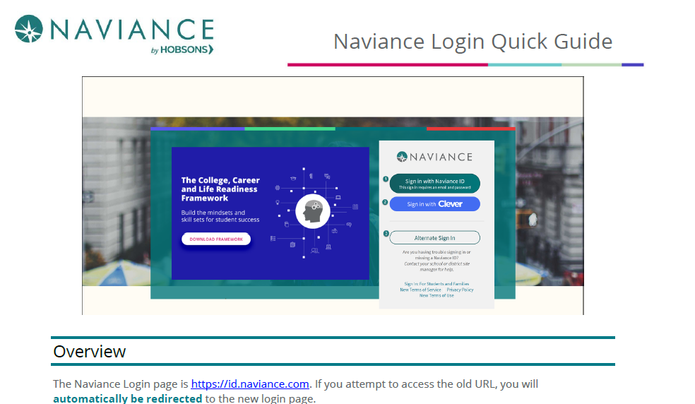

Go to the Naviance Login page: https://id.naviance.com.
Click “Sign in with Clever” button
Then enter your High School Name
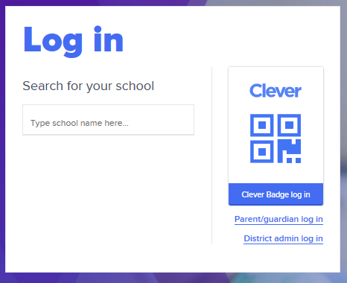
Next Login using your Clever Account Username and Password
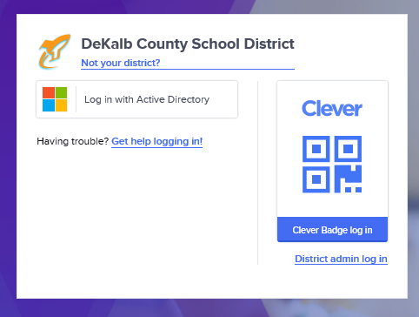
Once in Clever Account, Sign into the Naviance Icon (under the CTAE section)

Overview: How to navigate Naviance Student
